

Programming
Section (8)

Assignment Title
Programming using Java

Submitted to
Dr. Mariam Biltawi

Submitted by
Raghad Jaber 23110155

Part One:
- The process of building an application for a certain goal or for problem solving are:
- Define and understand the problem needed to build the application.
- Think of multiple ways to solve the problem and choose the best suited for the situation.
- Present the way of solving the problem in simple steps in an algorithm to show inputs and outputs.
- Write a code that implements the algorithm.
- Test the code for any errors such as logic, runtime, or syntax.
- Document the code.

- Algorithms are the methods of solving a certain problem after deciding the way of solving it. And it is the step before writing the actual code. Or we can define it as a sequence of activities to be processed for getting desired output from a given input. There are two ways of writing an algorithm pseudo code and flowcharts. Pseudo code is the way of expressing the algorithm logically by a clear written language without any coding details and its very similar to the human’s language. This helps in freeing the limits that coding has and Shortcut for learning a new programming language and focusing more on the steps of solving this problem. Flowcharts are diagrams which visually present the flow the sequence of an algorithm they are more common between programmers, but some ideas can’t be explained by this method because of the limitation of tools unlike pseudo codes where language tools are tools to describe pseudo code and it is clearer in terms of reading and showing details due to this pseudo code is considered as the connection point between the idea and the flow chart since the direct transformation between both pseudo code and the flowchart isn’t easy and clear. So, creating the pseudo code before the detailed flowchart then implementing the code by translating each algorithm into actual lines of code. Why write pseudo code? To speed up the process of Writing the Code, Selecting the appropriate language, Testing, and Debugging. And, to transfer programming ideas and coding mechanisms to decision makers from different fields such as data analytics, mathematicians, and company owners.

- There are some characteristics to have an efficient and effective algorithm such as:
- Clear and Unambiguous. Each algorithm line should be clear and easy to understand and transfer it to a line of code.
- Well-defined Inputs
- Well-defined Outputs. Outputs should correspond to the goal we want our code to reach.
- Finiteness. The algorithm should have a beginning and an end and doesn’t enter an endless cycle.
- Feasible. We can implement the solution.
- Language Independent. Can be implemented in any programming language not just one.
- Big O Notation. This allows us to compare the efficiency of different algorithms for solving the same problem. To determine how quickly which one will perform better for large input.

- Steps of writing a code for a program:
- Define the problem: Understand what the problem is you need to solve in your program.
- Create your algorithm: Break down the problem into smaller steps and create the sequence you need to follow by writing pseudo code or a flow chart.
- Write code: using any programming language.
- Test and debug: Run the program and check any errors either syntax, logical, or runtime.
- Refine and optimize try improving the program and making it more user friendly.
- Document your code: by adding comments to make it understandable by others.
- Finalize and release the program.

- Code Execution process:
- Source code: choosing the programming language of the code, for example choosing c as the programming language we will create code.c. or choosing java a java.c file will be created.
- Text Editor: such as Notepad, gedit.
- Compiler by using the terminal: gcc, javac.
- The result of compiling is Machine code file such as code.out, Byte Code, Code.class
- Interpreter for printing the output: for c ./code.out, and for java java code.
- Output: Hello c, Hello Java.

- Bubble sort algorithm is a sorting algorithm that goes through the list and compares elements values and swaps them if they are out of order. Then it sorts the array in ascending order or descending order.
Step One, go through all the indices in the array.
Step two, compare 1st and 2nd elements and swap if the 1st element is bigger for descending order. Or swap the 2nd element if you are arranging the array in ascending order.
Step three, Repeat Step two on all the indices in the array.
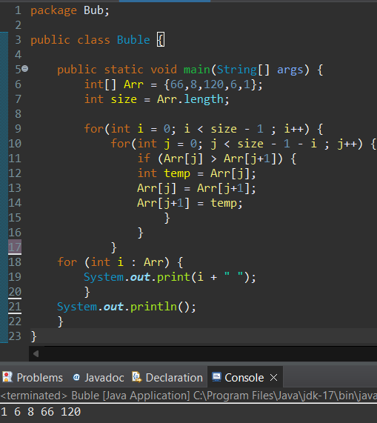

Part Two:
- The Procedural Programming paradigm is one of the Programming paradigm types. Where program code is divided up into procedures (functions or methods). We can describe it as a chain of instructions and logical steps that are executed line by line as a sequence from top to bottom to produce a certain output. But in some cases, there are certain situations that affect the sequence of the code. for instance, if statements that could result in execution of the code by jumping from certain lines if the conditional sentence is wrong. Or for loops that iterates in its scope. The key features for this programming paradigm to distinguish it from other paradigms are:
- Sequence control: clear starting and ending point for the code structure.
- Modularity: the code could be divided into separate functions to do tasks.
- Abstraction: Functions and procedures encapsulate complex tasks to simpler ones.
- Execution Control: it gives more control over the flow of execution.

- The Object-Oriented Programming paradigm (OOP) is one of the Programming paradigm types. It is the most popular programming paradigm since it implements real-world entities like inheritance, hiding, polymorphism, etc. Its main concept relies on the definition of classes and objects. A class is a blueprint that defines the attributes (variables) and the methods (functions) to code real life objects. It helps in binding data and methods together making it reusable for objects. An object is a copy of attributes and methods of a certain class, and we can create multiple objects from one class without affecting the other objects.
To build OOP you need constructors to do so. Constructors are methods that initialize an object of a class. It has the same name as the class and does not have a return type. There are multiple types of constructors such as the default constructor (e.g. Home () {}) it is responsible in constructing the objects in the memory and setting them in its default values. Another type is the parameterized constructor.
(e.g. Home (int members) {}) it takes one or more parameters. We can have multiple constructors in one class, and we call these constructions overloading. The Fundamentals of object-oriented programming:

- Encapsulation: It is a way of wrapping up data and functions together into a class such that they are kept safe from outside interference, And to control access modifiers (default, public, protected, and private). Moreover, it makes the class not directly assessable. Encapsulation is achieved by declaring Attributes to private (which means they can only be accessed within the class). To reach these attributes we need getters and setters. getters to return values with no parameters needed inside it. setters are to set values (initialize)
- Inheritance: It is the concept of letting a new class adopt the properties of another. The original class is called the parent or the superclass. And the inheriting class a subclass or a child class. The subclass inherits all the public and private attributes and methods of the superclass and adds new ones too. There are multiple types of inheritance such as single inheritance, multi-level inheritance where we have a parent and child and the child is also a parent for another child class where it inherited the first parent attribute and its child and its own attributes, and the last type is hierarchical inheritance which a single parent class has multiple children.
- Polymorphism: It is a way to perform a single action in different ways. In other words, polymorphism allows you to define one interface and have multiple implementations. So, Inheritance lets us inherit attributes and methods from another class polymorphism uses those methods to perform different tasks. There are two types of polymorphisms Overloading and Overriding. Overloading
When there are multiple functions with the same name but different parameters with different data types. We call an Overriding method when a method in a subclass has the same name, the same parameters or signature, and the same return type (or sub-type).

- It is a programming paradigm where the execution of a program relates to the accuracy of a certain event. It is also described as the action that leads to an event. It is made of event action and listener.
Event driven cycle elements:
1. events: trigger an action within the system
2. actions: Actions are the responses performed when an event occurs
3. listener (loop process): is the medium between events and actions
The core difference between Event driven and OOP and procedural paradigms is the ability to implement the code into a graphical user interface which is an easier approach for the user to apply their actions like clicks keystrokes or mouse movements unlike procedural and OP paradigms which they deal with the user by the conceal. The differences between OOP and EDP. Is that event driven flow of the program is determined by the events of the user's actions mouse clicks or key presses but in object oriented the program is divided into small parts called objects and its mechanism is implemented by using the concept of objects that interacts with the real world generally object oriented is more based on real world and it follows the bottom up approach while executing the program therefore it provides data hiding so it is more secure. And the differences between procedural and event driven paradigm the procedural is divided into smaller parts called procedures and the execution follows top to down approach and driven follows its cycle of actions listeners and events to execute the code. Another different feature is the blocking which procedures keeps going into each block until the execution is completed, I mean the user can't input in the code until the previous input is already executed which makes the program less responsive unlike invented driven which is non-blocking which means that the program can handle multiple events at the same time why tasks are being completed.

My scenario is tataki restaurant which is a restaurant that sells sushi and poke bowls at first I asked the user to enter whether they want a poke bowl or a sushi roll then they will build the dish with me by entering how much protein toppings they want then selecting the number of the ingredients they want and then chose the number of the ingredient they want. The same method for protein, extra, and sauces. The total price and calories are shown and a sorted list of calories using bubble sort algorithim.
Procedural:
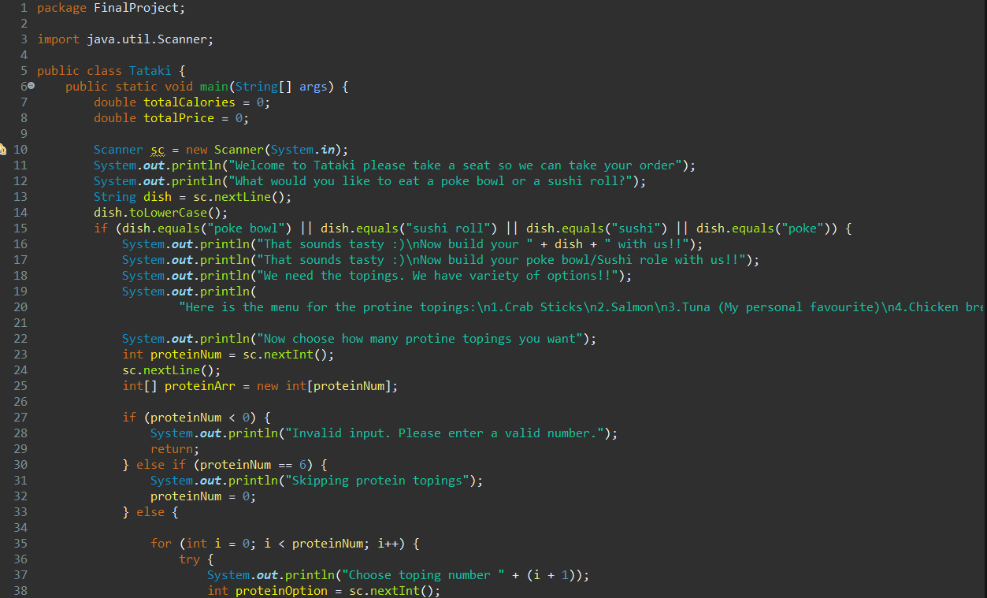
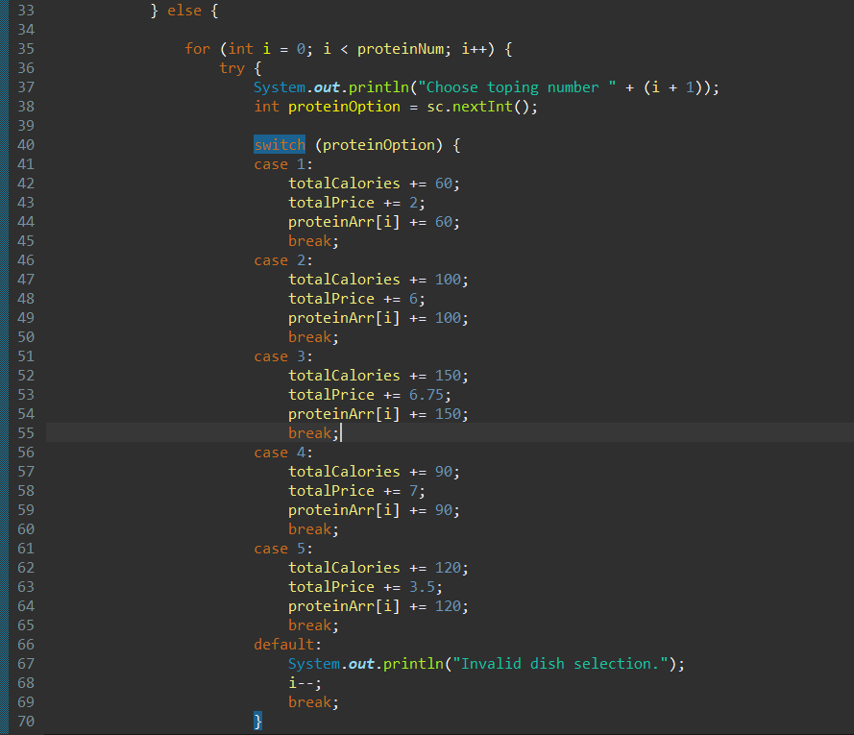
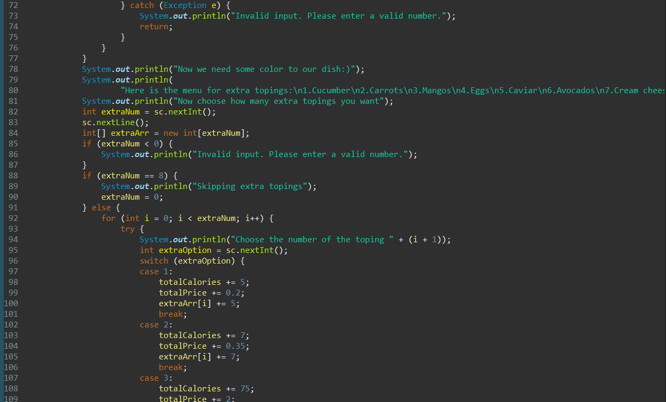
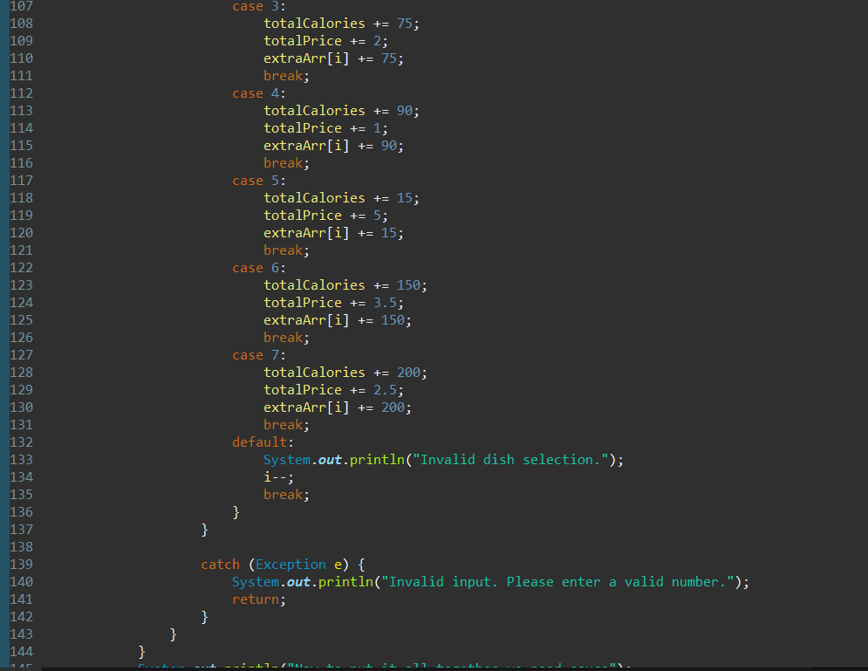
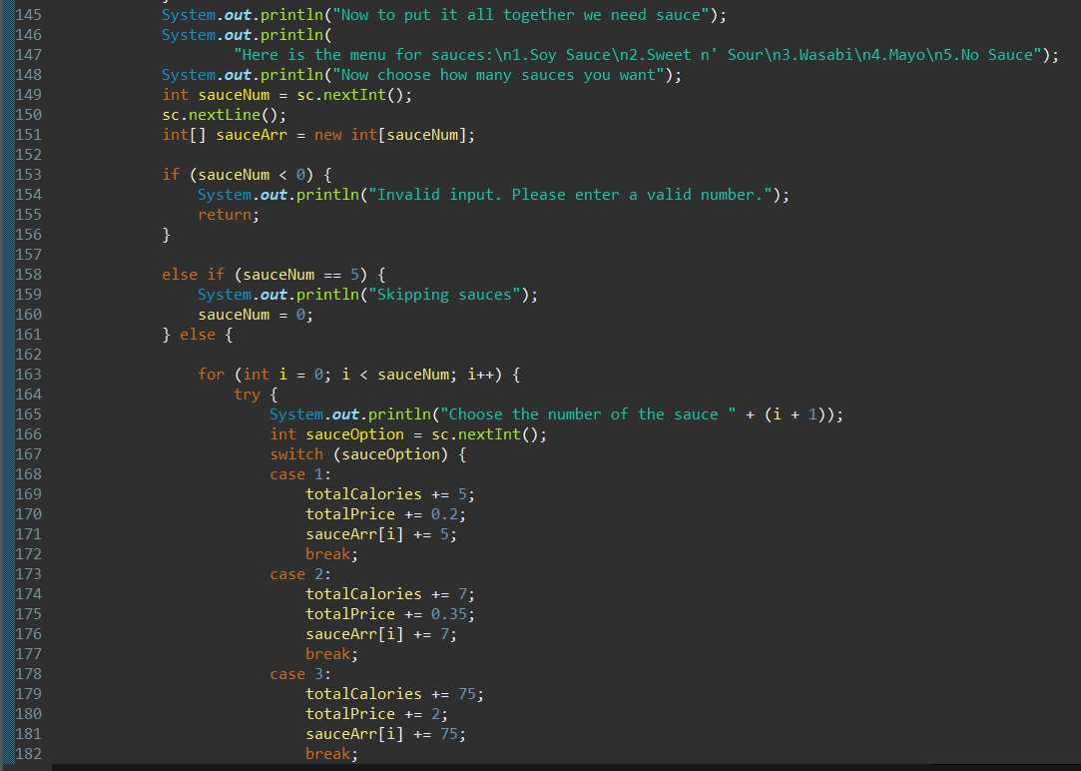
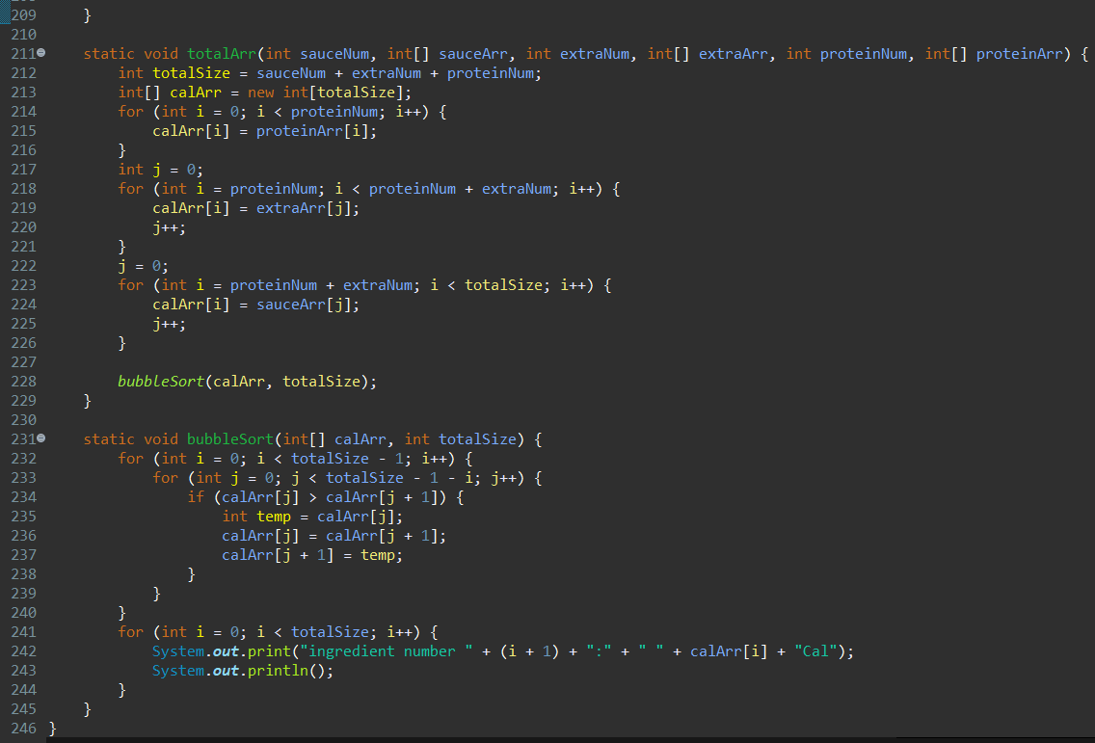
In procedural I used functions if statements for loop switches to implement the code. As functions helped me to include my algorithm. if statements helped with running the procedure as I wanted. Moreover, adding switches with the cases that I want the Code to go into. But if I use classes, it would be much easier to create ingredients with their calories and price with more organized format and more security on data other than using libraries for array storing “array lists”. And displaying final bill.
OOP:
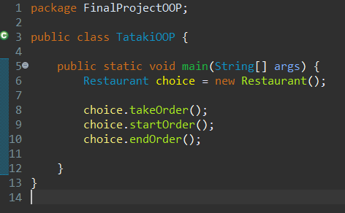
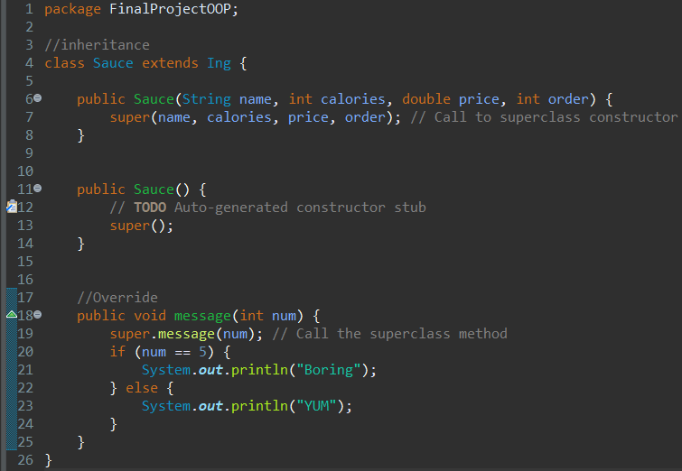
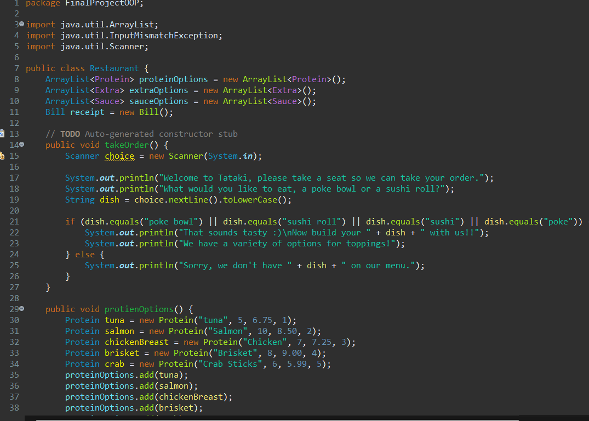
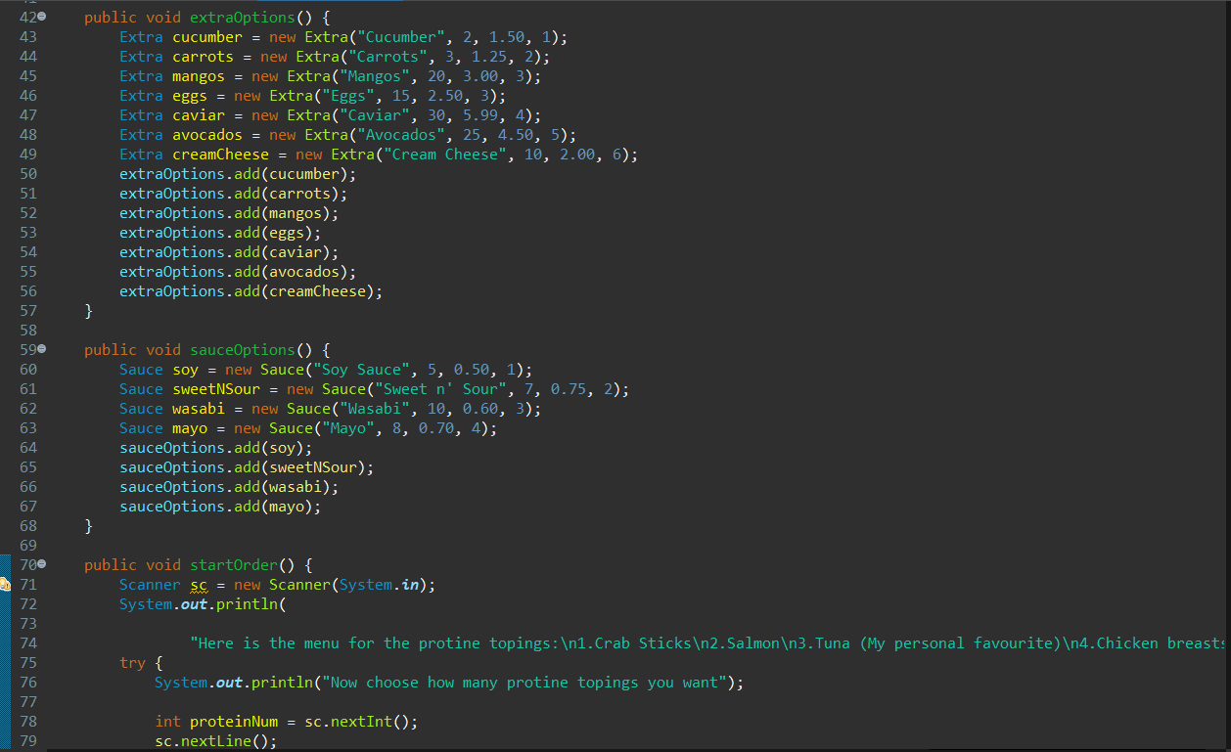
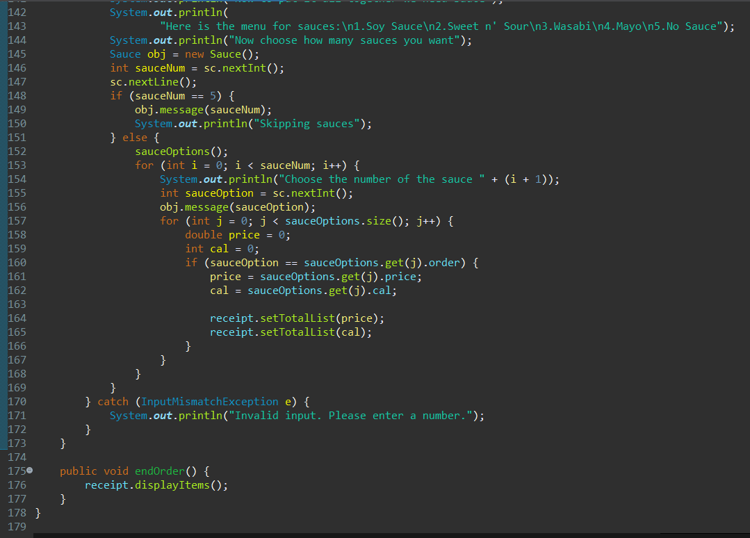
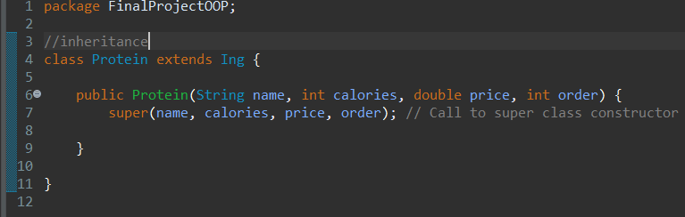
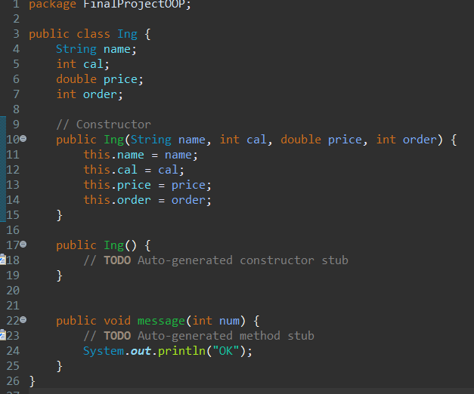
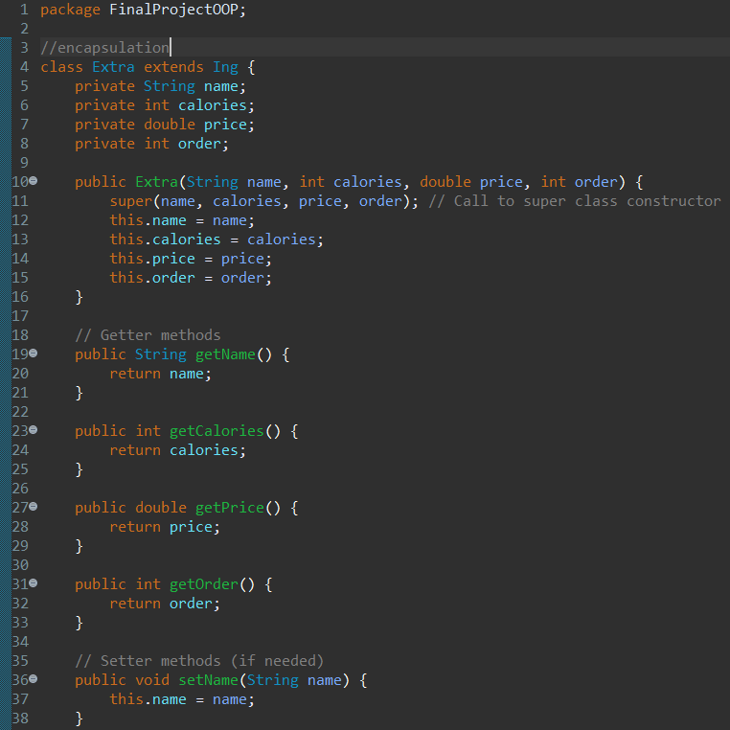
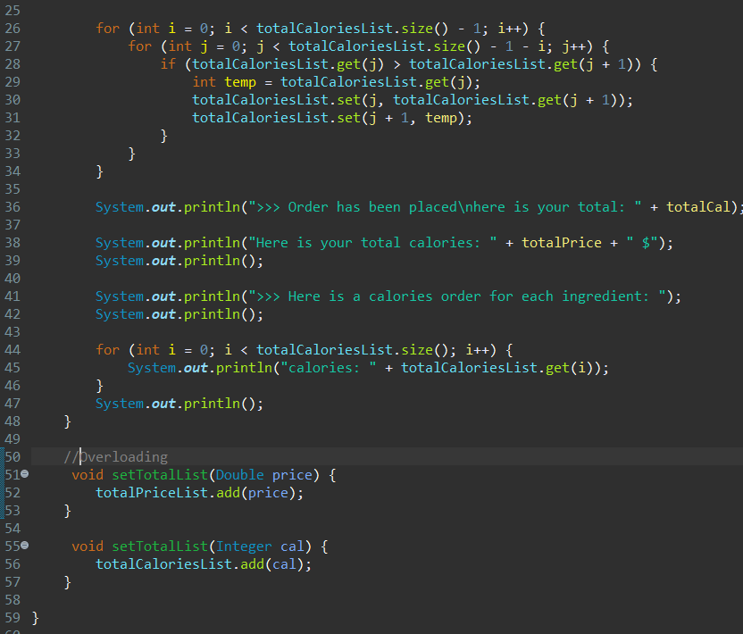
As it is represented the main function in the OOP is much smaller and simpler than the procedural this is an advantage since it is easier for documentation and for other programmers if they want to add or use the code, they will know exactly what the code is. by just looking at the names of objects and classes created in the main function. I started building the code by creating the restaurant class in this class I created three functions the startOrder, endOrder and takeOrder. Also created other functions to create objects for the extra, protein, and sauces classes. These are inherited classes from the parent class which is Ing. By this I was able to assign the attributes to the array lists that are in the main ingredient class. I used polymorphism overloading by displaying the price and calories total which helped in code reusability. And polymorphisim overriding in the sauce a child class for extra context. Also using encapsulation for more flexibility on the code. I also created Bill class for more organization to display the total prices and for the bubble sort algorithm. Libraries helped me in many aspects such as try and catch that helped me with exceptions and debugging.

EDP:
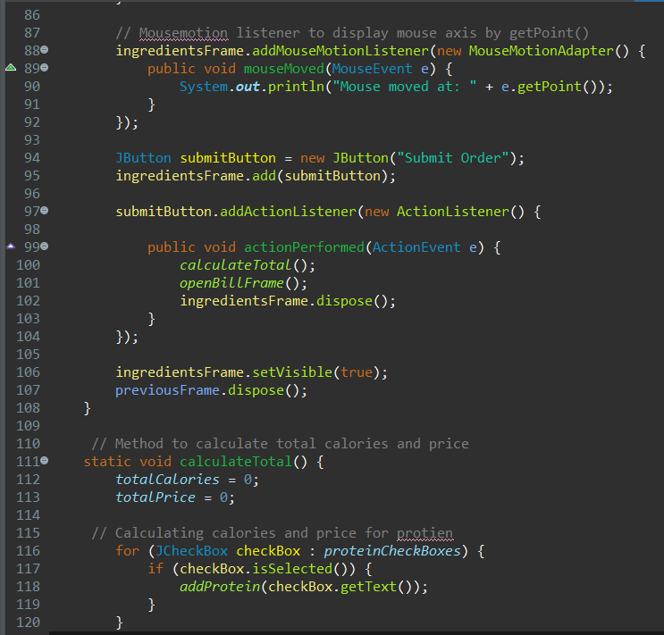
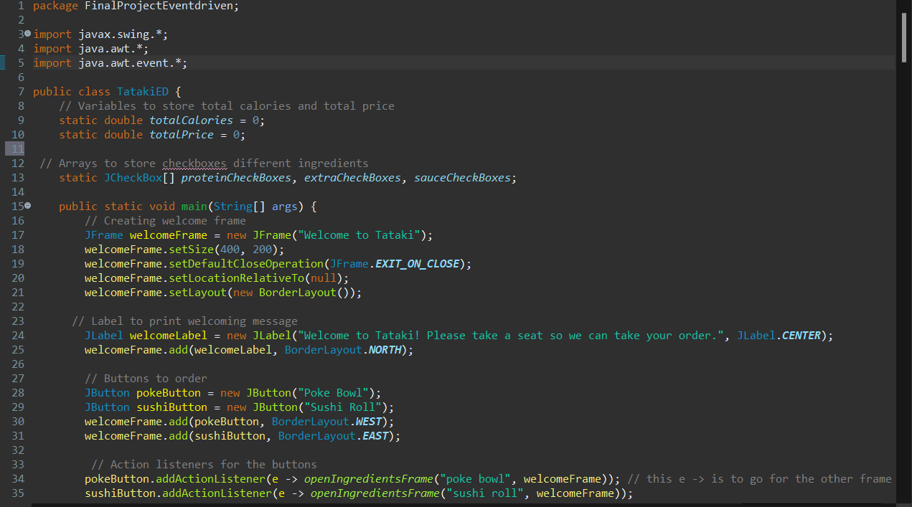
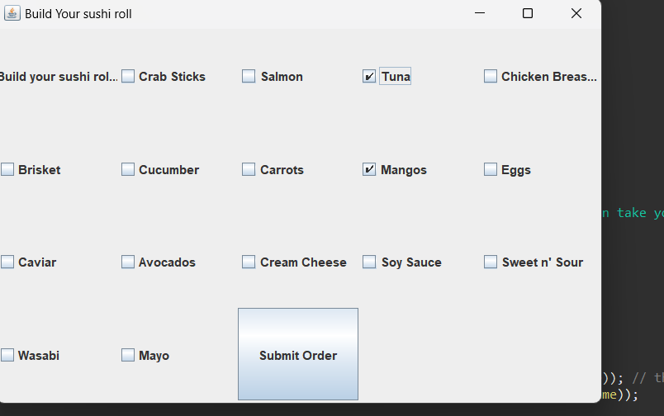
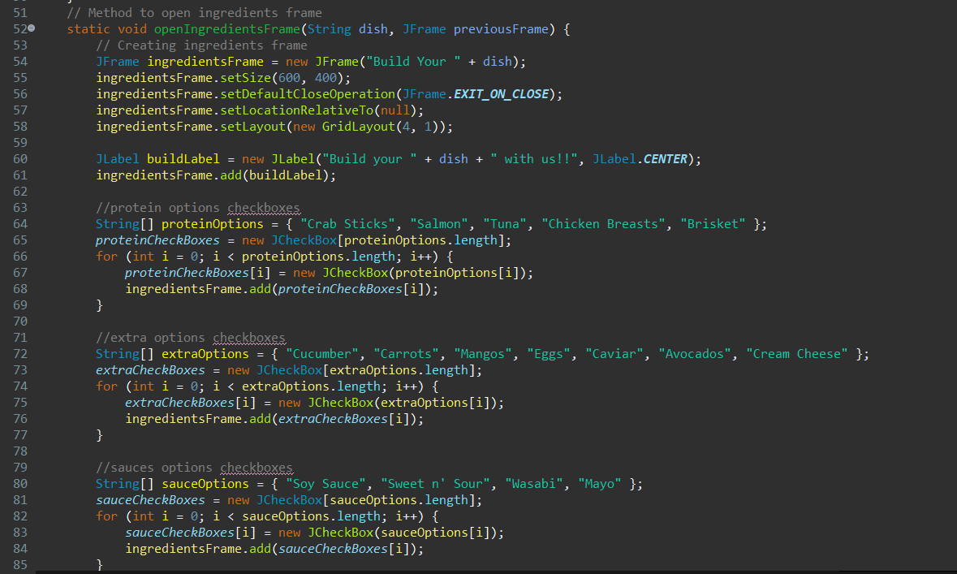
Generally, Event driven is more user-friendly due to its graphical user interface features since it is much easier for the user to assign their input and see the output more clearly also EDP is more reliable and suitable for real life scenarios since in my application you can fully see the ingredients and mix whatever ingredients you want without displaying each category alone. I used buttons checkboxes for easier access and by implementing action listeners for multiple things such as triggering buttons and checking the selected check and storing calories and prices with the help of arrays and functions. And manipulating functions and arrays for storing their calories and prices. other than the Usage of the key listener for smooth transitions between frames. which helped in the welcoming frame to transfer to the ingredient frame whether the user clicked on sushi or poke bowl button. And the mouse motion listener to dedicate the movement of the mouse.
- We consider a code to be well-documented and readable by others by taking these aspects into account:
- Initializing attributes by Meaningful Name
- Write Comments to explain complex logic and algorithms.
- Documentation
- The importance of testing code before execution scopes in helping with Identifying Bugs from the begging before they become more deeply embedded in the code and get more complicated to find. it also reveals security weaknesses and data loss of sensitive information. Tested codes are easier to update since the risk of introducing new bugs is minimized.

Part Three:
- The steps you take to create a new project in IDE eclipse:

1. Go to Workspace (Main directory)

2. Click Create java project

3. Name your project and note that when naming the project consider: no spacing, no capital letters at the beginning and make sure to uncheck the create module info.

4. Then check whether you want your project to have a source folder or not.

If we want to create a project when we already have one on the workspace, follow these steps:

1. click right click. 2. New 3. java project

After following these steps, you will have a project that is empty, and you can fill it with packages and classes to manage your files.

1.Package: By clicking on right-click on the src folder, click on New then Package to create a new package.

2. class (object oriented '.java'): By right-clicking on the package, choose New then Class to create a new class file.

Managing Directories: When creating a new Project in Eclipse it automatically sets up the basic directory structure, including the src directory. But when unchecking Source Folders you won’t have the src directory.

Note: to know the directory of a project press right click -> proprieties -> location.
- features or tools provided by IDEs:
- Auto completion Warning messages, Easy completing the lines of codes (ctrl+space)
- The tooltip explains the reason for the compilation error. Adding comments (ctrl + shift + /)
- Project management (classes + packages inside project)
- Renaming variables and classes (right click + refactor -> rename)
- Indentation control (ctrl + shift + f)
- Syntax Highlighting Differentiates elements of the code.
- Debugging Tool

- Breakpoints are signals that tell the user to suspend execution of your program at a certain point in the code. This lets you examine the program memory and behavior. During building my application I ran into multiple errors while implementing array lists objects and variable since they were hard to examine all at once by the break tool I was able to track the variables inside the arrays and the objects inside the array lists whenever I run into logical errors and runtime errors it also is simplify the execution of the code since the Breakpoints allow me to scope to a certain line of codes this helped me since my code is large and the bug that I need to track is in a certain lines

- Speed, Efficiency, and ease of use in IDE:
- Speed: It speeds the syntax writing process since it offers features like code completion, syntax highlighting, and snippets. Error Detection since it offers debugging tools which help in finding issues quickly, reducing time spent on debugging. Debugging without tools requires manually checking the code, which is more time-consuming.

B. Efficiency: IDEs have refactoring features that help in improving the structure, readability, and maintainability of your code.

C. Ease of use: provide an interface which can be more user-friendly unlike other compilers that don’t support interfaces that leads to complexity in using console. Customization of projects classes and objects is another feature in IDE that makes it easier in files.

Part Four:

1- Types of errors:

1. Run Time Error: Run Time errors are detected during the execution of the program. It is detected by JVM (Java Virtual Machine). These errors are unpredictable as the code compiles correctly and may run smoothly under some situations but does something either unexpected or incorrect in others. To handle the situation, we will need exception handling which are mechanisms an eclipse to handle these errors such as ClassNotFoundException, IOException, SQLException, RemoteException, try catch block, etc. There are two types of java exceptions checked and unchecked.

2. Syntax Error: you need to have a properly formatted code to let the compiler understand your code and run it. Syntax errors are Spelling, or grammatical mistakes often spotted as you type depending on the compiler you are using, they are handled by highlighters and comments even if you try to compile your code the program will crash and fail to compile.

3. Compile Time Error: errors that prevent the code from running because of an incorrect syntax such as a missing semicolon at the end of a statement or a missing bracket, class not found, etc. These errors are spotted by the java compiler. These errors are oftenly referred to as Syntax errors.

4. Logical errors: this is the most complicated in finding it since it doesn't cause any type of error from the compiler since it will compile and run successfully however the output will not correspond with the programmer's goal. These errors are detected by debugging methods such as breakpoints and running the code as debugging when provide a tool set for complex issues as you carefully monitor memory and so on.

2- Steps of Debugging:
  - Identify the Error
  - Find the bug’s Location: in which class and project is your error.
  - Understanding the bug
  - Determine the root cause: by examining the logic and flow of the code.
  - Fix & validate the bug: troubleshooting and revising the code to check if there are any more issues, and recompiling and re-running the code to make sure the bug is fixed.
  - Document the process: developers do this to show what caused the bug, how it was fixed. This helps in finding similar bugs that could occur in the future.

3- Breakpoints stop the execution of the code at your desired location. And then running the program in debug mode. Here are the steps to implement a breakpoint:
  - Click on the codes edge that you want to stop the execution in and start debugging in.
  - After implementing the breakpoint run the code as debugging.
  - After entering the debugging mode debugging tools will appear. Using them you will be able to terminate the debugging process, step into which helps in seeing the detailed behavior inside the function called, step over that executes the next line of code but skips over any functions called on that line, treating them as a single line of code, and step return It is used to exit the current function and return to the calling function.

4- Debugging is essential for troubleshooting and fixing bugs during building an application. while debugging if you encounter extra codes and then getting rid of them this ensures reliability of the code and it also helps in checking if the application is working correctly and safely in different situations, so if different users are using it data is secured and distinguished from user to user. Also, developers should be cautious when debugging, especially with sensitive blocks, to avoid any potential security issues and to track the code flow and any data loss. Moreover, debugging is crucial for reverse engineers (The process of disassembling a piece of software, followed by a thorough analysis of its functions and logic to fully understand its behavior). Since debugging allows attackers to understand the internal workings and logic of an application. This understanding can be exploited to design imitation apps containing malicious code. With these codes attackers can tamper with the application by injecting malicious code. Overall, following these guidelines helps prevent mistakes and keeps the app secure from the start.
- Runtime error: I had problem when the user entered an invalid input such as a string or a negative number or a character so by handling this exception with try and catch, I was able to ensure the suitable input from the user. I applied the try and catch in procedural and OOP.

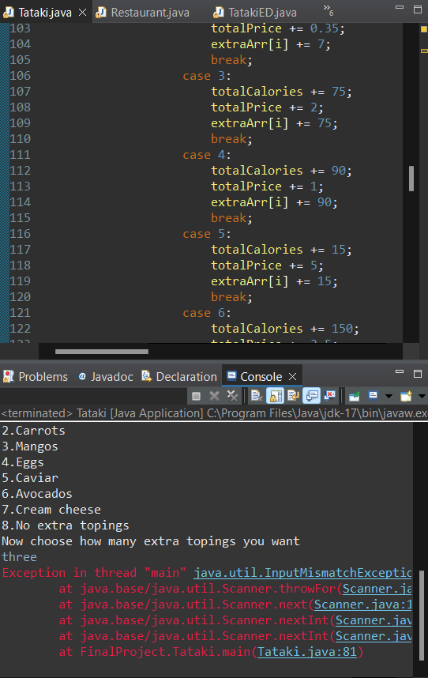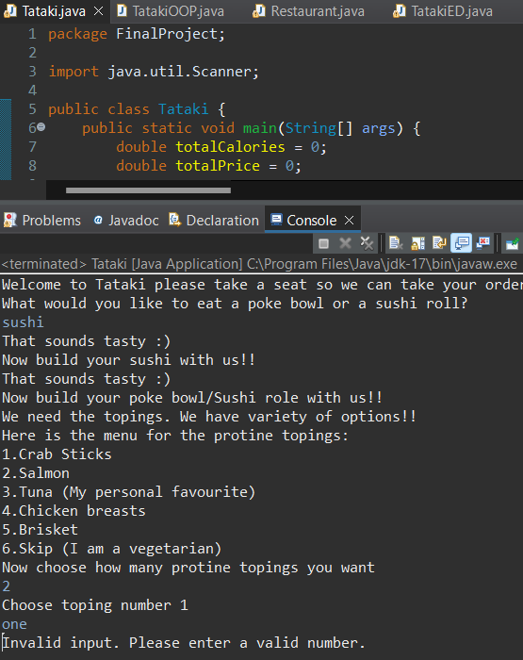

I used another method to ensure a correct input from the user for exception handling by using the built in function toLowerCase() so that the user can input and any case and the code won’t stop.

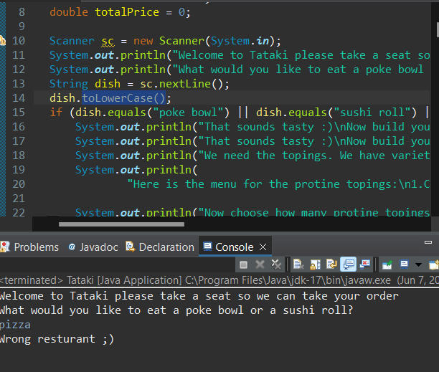

Syntax:
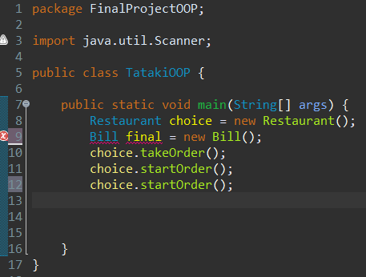

I used final as an object name and I ran the code. I was surprised that it had an error and then I found out that this word is reserved since it is highlighted.

Logical:

In the startOrder function when the code asked about the number of proteins toppings, I forgot to add the protein topping’s function where they were defined in the array list. Due to this the output didn't appear the ingredients of protein that the user chose since it's only initialized inside the function scope. Adding the function inside the scope the array list of protein toppings is initialized and known then the ingredients are printed successfully.

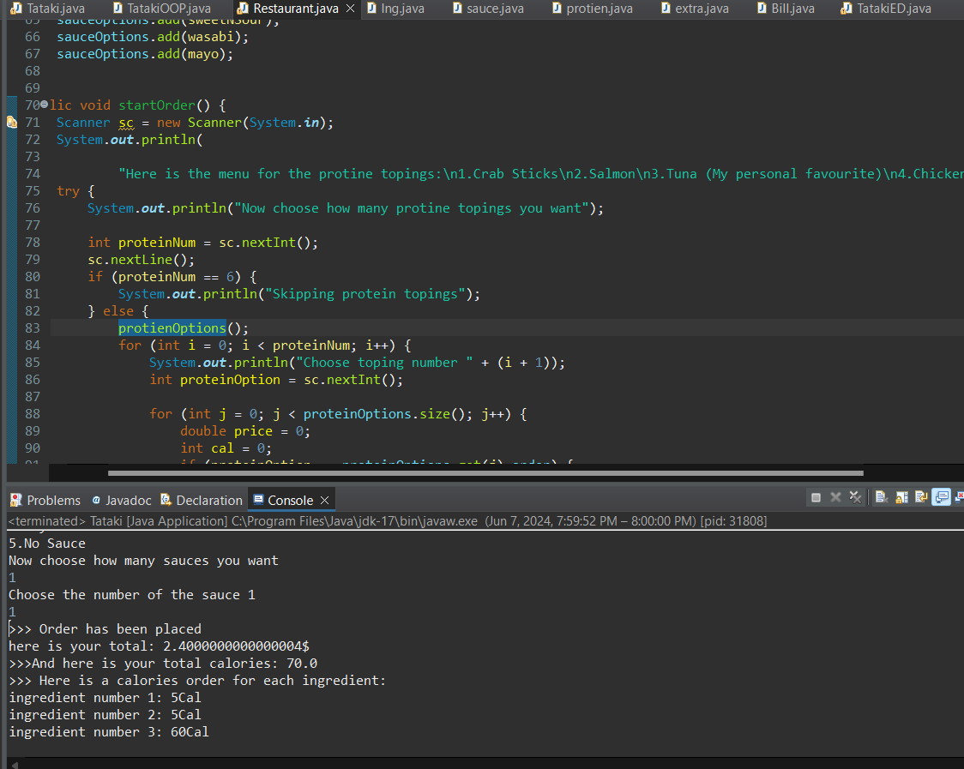
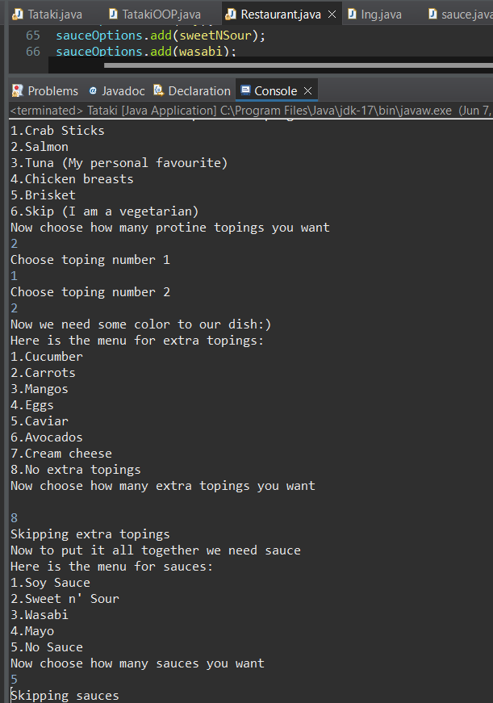

Part Five:
- coding standards do you follow when writing code:
- Naming conventions
  - pascal case -> capatalizing each word such as ProgramOne. Used for classes names.
  - camel case -> Used for variables and methods. For example, studentName.
  - Snake case with uppercase -> often for naming constants and global variables. For example, MIN_WIDTH.
- Indentation
- The opening and closing brace’s location.
- One declaration per line (Variables)
- One statement per line

- By following naming convention rules throughout building my application, I was able to easily understand and interpret the meaning of different variables, functions, and classes. Moreover, Naming conventions help distinguish between different types of variables and attributes. And when naming different variables this helps with Self-Documentation which leads to reducing the need for additional comments.

- A coding standard ensures that all team members follow the same rhythm leading to consistent features across the code. Which makes it easier to read, understand, and maintain, as team members can easily negotiate through the code structure. This leads us to good collaboration as it results in healthy communication and reduces conflicts. And it also improves the codes quality as it makes it more readable to the most audience and increases the quality of the code as it tracks any bugs and makes it easier to find.

References:
Ada Computer Science Education:

ADA Computer Science Education. (n.d.). Programming Paradigm. Retrieved from https://adacomputerscience.org/concepts/procprog_paradigm?examBoard=all&stage=all
Brainly:

Brainly. (n.d.). Retrieved from https://brainly.com/question/10848659
GeeksforGeeks (Bubble Sort):

GeeksforGeeks. (n.d.). Bubble Sort. Retrieved from https://www.geeksforgeeks.org/bubble-sort/
Vaia Study Set:

Vaia. (n.d.). Retrieved from https://app.vaia.com/studyset/16476842/summary/70417943
Educative.io (Object-Oriented Programming):

Educative.io. (n.d.). Object-Oriented Programming. Retrieved from https://www.educative.io/blog/object-oriented-programming#what-is-oop
GeeksforGeeks (Introduction of Object-Oriented Programming):

GeeksforGeeks. (n.d.). Introduction of Object-Oriented Programming. Retrieved from https://www.geeksforgeeks.org/introduction-of-object-oriented-programming/
CodeGym:

CodeGym. (n.d.). Principles of OOP. Retrieved from https://codegym.cc/groups/posts/159-principles-of-oop
GeeksforGeeks (Encapsulation in Java):

GeeksforGeeks. (n.d.). Encapsulation in Java. Retrieved from https://www.geeksforgeeks.org/encapsulation-in-java/
Stackify:

Stackify. (n.d.). OOPs Concepts in Java. Retrieved from https://stackify.com/oops-concepts-in-java/#:~:text=The%20main%20ideas%20behind%20Java's,%2C%20encapsulation%2C%20inheritance%20and%20polymorphism.
GeeksforGeeks (Polymorphism in Java):

GeeksforGeeks. (n.d.). Polymorphism in Java. Retrieved from https://www.geeksforgeeks.org/polymorphism-in-java/
BairesDev:

BairesDev. (n.d.). 5 Tips for Writing Clean and Maintainable Code. Retrieved from https://www.bairesdev.com/blog/5-tips-for-writing-clean-and-maintainable-code/
GeeksforGeeks (Coding Standards and Guidelines):

GeeksforGeeks. (n.d.). Coding Standards and Guidelines. Retrieved from https://www.geeksforgeeks.org/coding-standards-and-guidelines/#what-is-coding-standards-and-guidelines
Eclipse Help Documentation:

Eclipse. (n.d.). Help Documentation. Retrieved from https://help.eclipse.org/latest/index.jsp?nav=%2F1
Eclipse Community Newsletter:

Eclipse Community. (2017, June). Breakpoints. Retrieved from https://www.eclipse.org/community/eclipse_newsletter/2017/june/article1.php#:~:text=Breakpoints,double%2Dclick%20on%20this%20position.
JetBrains IntelliJ IDEA Help:

JetBrains. (n.d.). Using Breakpoints. Retrieved from https://www.jetbrains.com/help/idea/using-breakpoints.html#breakpoint-types
Scribd:

Scribd. (n.d.). M2 Final Document. Retrieved from https://www.scribd.com/presentation/556672658/M2-final-doc
Stack Overflow:

Stack Overflow. (n.d.). Event-Driven Architecture Infinite Loop. Retrieved from https://stackoverflow.com/questions/3688117/event-driven-architecture-infinite-loop
Medium:

Medium. (n.d.). What Does Event-Driven and Non-Blocking I/O Mean? Retrieved from https://medium.com/@abshirj05/what-does-event-driven-and-non-blocking-i-o-mean-57ac4f54288e
DeepSource (Procedural Programming):

DeepSource. (n.d.). Procedural Programming. Retrieved from https://deepsource.com/glossary/procedural-programming
Javatpoint (Types of Errors in Java):

Javatpoint. (n.d.). Types of Errors in Java with Examples. Retrieved from https://www.geeksforgeeks.org/types-of-errors-in-java-with-examples/
Javatpoint (Exception Handling in Java):

Javatpoint. (n.d.). Exception Handling in Java. Retrieved from https://www.javatpoint.com/exception-handling-in-java
GeeksforGeeks (Exceptions in Java):

GeeksforGeeks. (n.d.). Exceptions in Java. Retrieved from https://www.geeksforgeeks.org/exceptions-in-java/
CodeHS:

CodeHS. (n.d.). Errors in Java. Retrieved from https://codehs.com/tutorial/david/errors-in-java
GeeksforGeeks (How to Debug a Java Project in Eclipse):

GeeksforGeeks. (n.d.). How to Debug a Java Project in Eclipse. Retrieved from https://www.geeksforgeeks.org/how-to-debug-a-java-project-in-eclipse/
PrepBytes:

PrepBytes. (n.d.). What is Debugging? Retrieved from https://www.prepbytes.com/blog/general/what-is-debugging/
Cybersecurity@UC (What is Debugging?):

Cybersecurity@UC. (n.d.). What is Debugging? Retrieved from https://cybersecurity.asee.io/blog/what-is-debugging/
Oracle Documentation:

Oracle. (n.d.). Appendix A. Retrieved from

